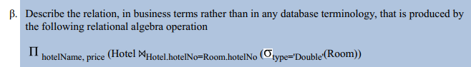
Show the prices and the name of the hotels that have rooms that are of type double.
Extra Practice:
select hotelName, Room.price
from Hotel
join Room on Room.hotelNo=Hotel.hotelNo
WHERE type = 'Double'
